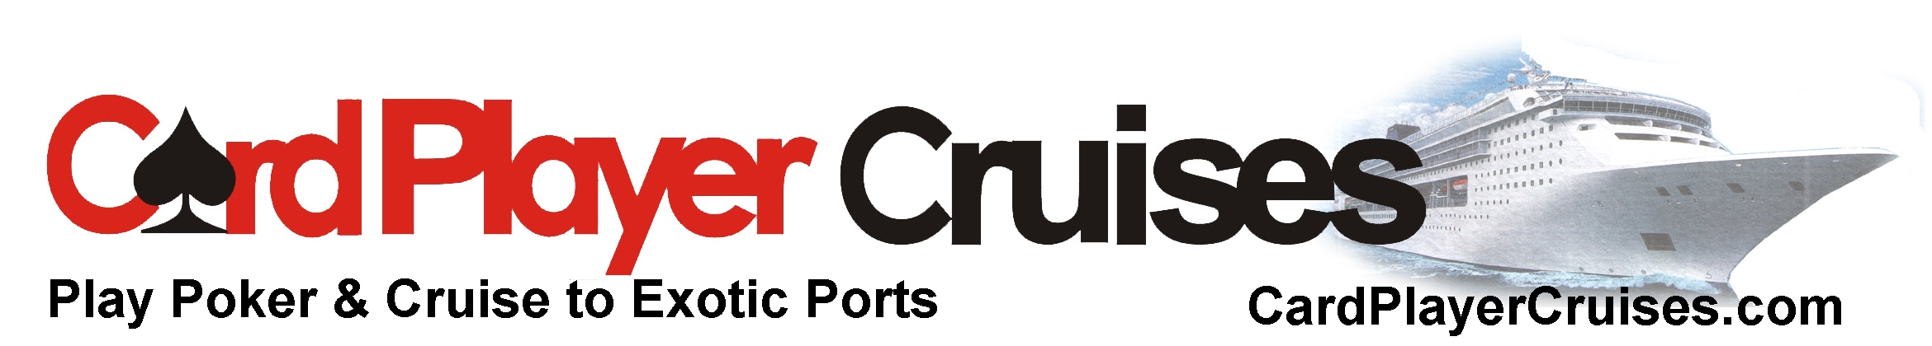
Please join us for our
7 night Scandinavia & Russia Cruise
Aboard Royal Caribbean’s Serenade of the Seas
Departing August 13, 2016 from Copenhagen, Denmark
From TBA per person
* Not including taxes

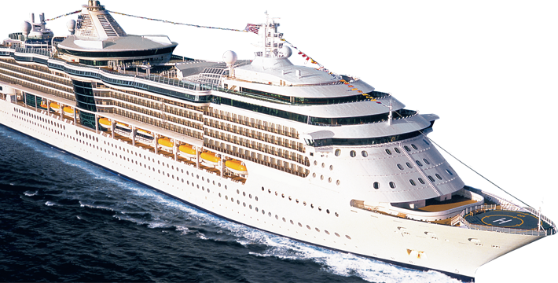 | 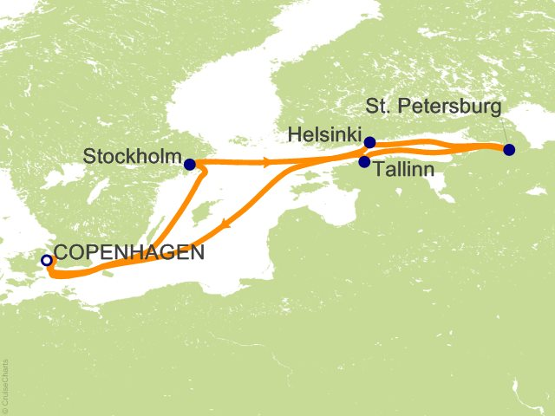

Bookings must be made through Card Player Cruises
to have access to the poker room.

Itinerary

Date | Port/City | Activity | Arrival | Departure
Day 1 | Copenhagen, Denmark |  |  | 5:00 p.m.
Day 2 | At Sea
Day 3 | Stockholm, Sweden | Docked | 9:00 a.m. | 5:00 p.m.
Day 4 | Tallinn, Estonia | Docked | 9:30 a.m. | 5:30 p.m.
Day 5 | St Petersburg, Russia | Docked | 7:00 a.m. | 7:30 p.m.
Day 6 | Helsinki, Finland | Docked | 7:00 a.m. | 2:00 p.m.
Day 7 | At Sea
Day 8 | Copenhagen, Denmark | 7:00 a.m.
All itineraries are subject to change without notice.

Please join us for this exciting cruise.

Cruise Highlights

Card Player Cruises invites you to visit these exotic ports with us!

Departing from Copenhagen, Denmark, Scandinavia's largest city is a treasure trove of art, history, architecture and modern design. Copenhagen artfully mixes fairy-tale settings like palaces, castles and elegant gardens with cutting-edge style and contemporary chic.

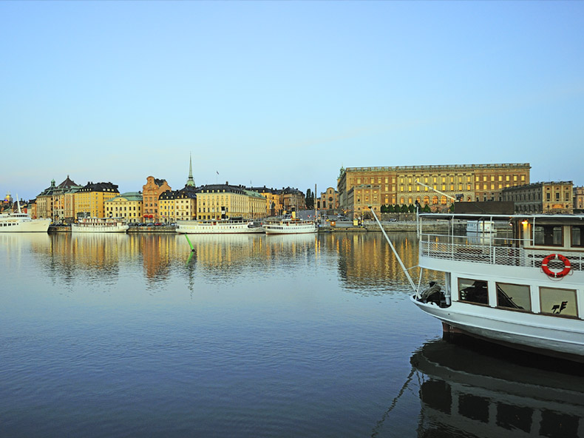 | Stockholm, Sweden:  Water and green space are never far away in the stylish Swedish capital, built on 14 islands with acres of parks. But don’t miss the medieval Old Town, whose narrowing streets are lined with unique shops, art galleries and cafés.
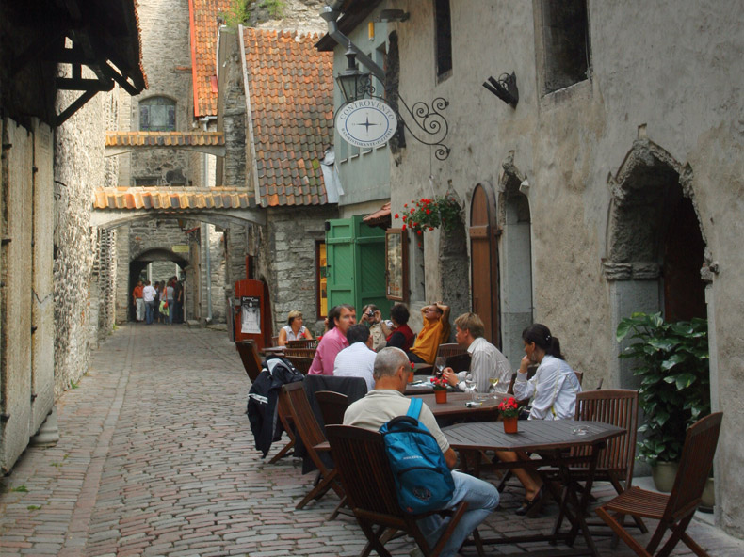 |  | Tallinn, Estonia:  Tallinn charms with lively cafes, cool galleries and medieval heritage. Stone walls circle its preserved Old Town, where the Estonian parliament meets in a 13th-century castle whose hilltop location offers the best views.
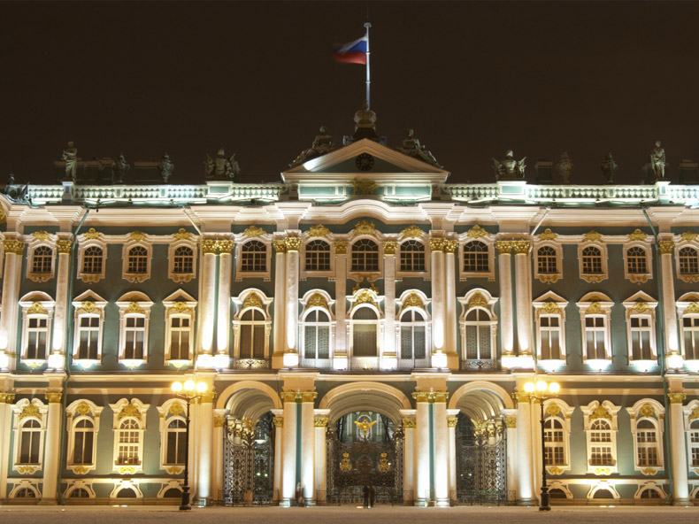 |  | St Petersburg, Russia:  Elaborate palaces, grand churches, sumptuous estates, and gilded façades: St. Petersburg is rich in architectural masterpieces and artistic treasures. Enjoy the culture and grandeur of this historic city built by the tsars.
 |  | Helsinki, Finland:  Discover the national pride of the Finnish people along with the Swedish and Russian legacy in this beautiful capital. Helsinki is filled with graceful architecture and monuments and surrounded on three sides by sea and tiny islands.

Staterooms - Serenade of the Seas
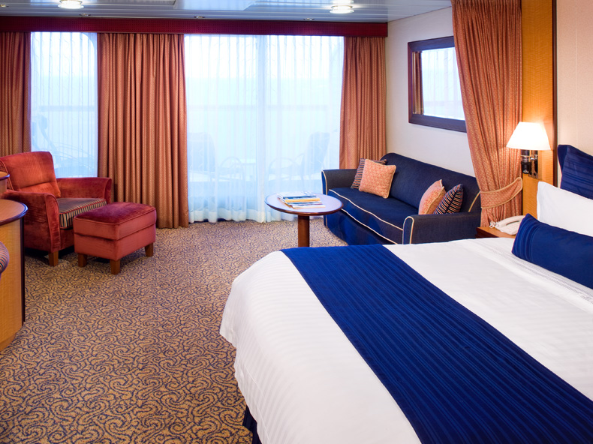
Owner's Suite, Grand Suite, Junior Suite
Suites offer more room, comfort and luxury. Most come with a private balcony and all include standard features. Some suites even include complimentary concierge service, which includes access to a private lounge as well as personalized service to help with making reservations or other arrangements. Suites are a great way to travel in style and give your family more space, while keeping everyone together. Private balcony, sitting area, vanity area, concierge service, minibar, hair dryer, tv, stereo, DVD player, phone, 110/220 electrical outlets, priority check-in and departure lounge, VIP seating at the pool deck and theater, priority tender tickets, complimentary luggage valet service, luxury spa bathrobes, and more. Stateroom and balcony sizes vary. Please contact our office for details.
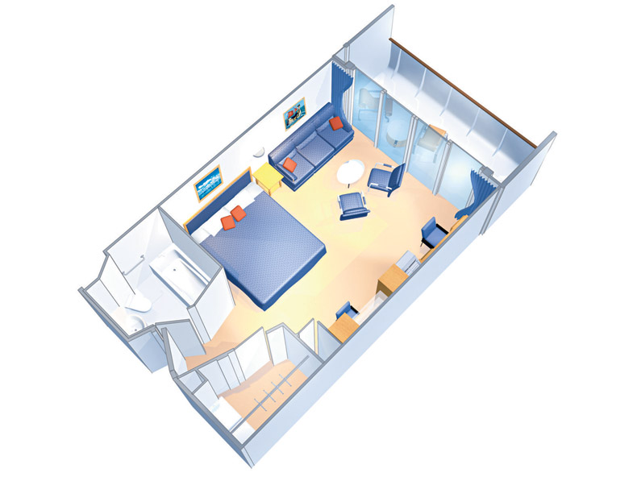
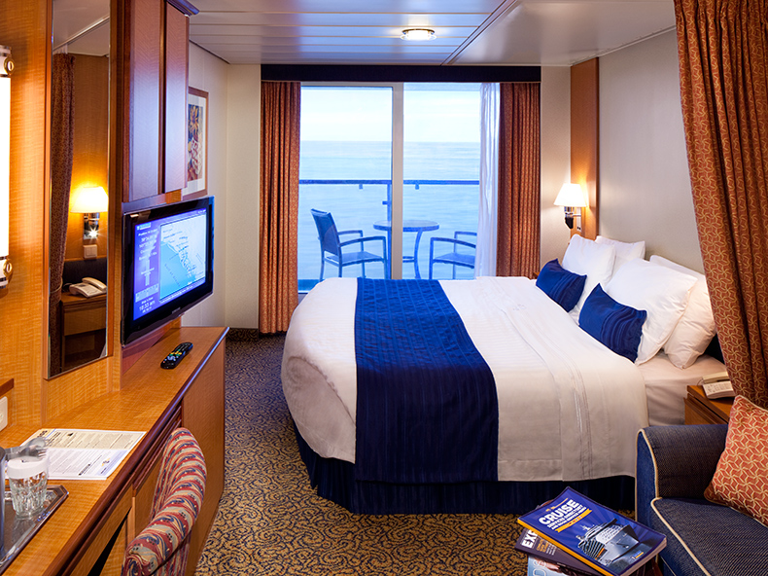
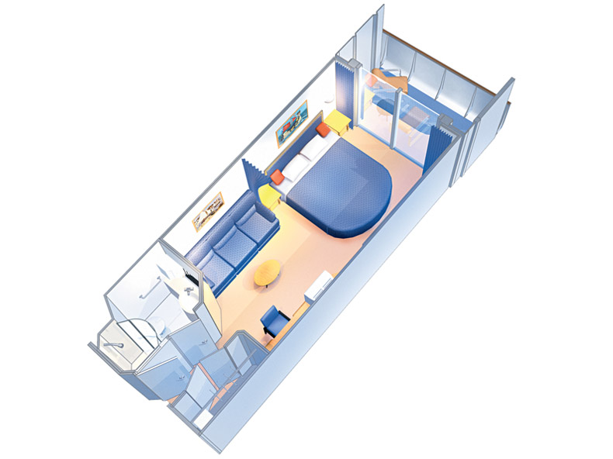Balcony Staterooms:
Imagine opening your balcony door to see a new and breathtaking part of the world each morning. A stateroom with a balcony is a great way to make your cruise adventure even more memorable and truly take in your destination. Balconies offer a spectacular view, small sitting area, and a private balcony. Room and balcony sizes vary. Please contact our office for details. Amenities include 110/220 electrical outlets, hair dryer, TV, phone, minibar, and more.

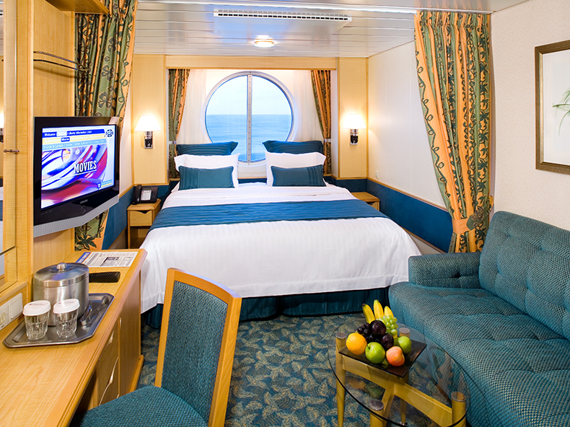
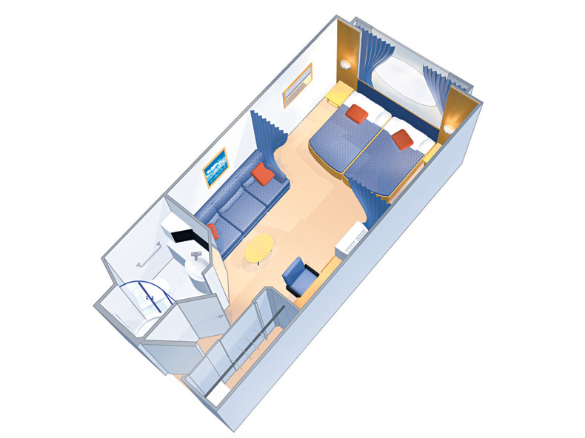
Ocean View:
You'll never miss a moment of the breathtaking scenery just outside your window. Amenities include 2 twin beds (can convert to a Royal King, measuring 72.5 inches wide by 82 inches long), sitting area with sofa, vanity area, minibar, hair dryer, TV, Phone, 10/220 electrical outlets, and more.
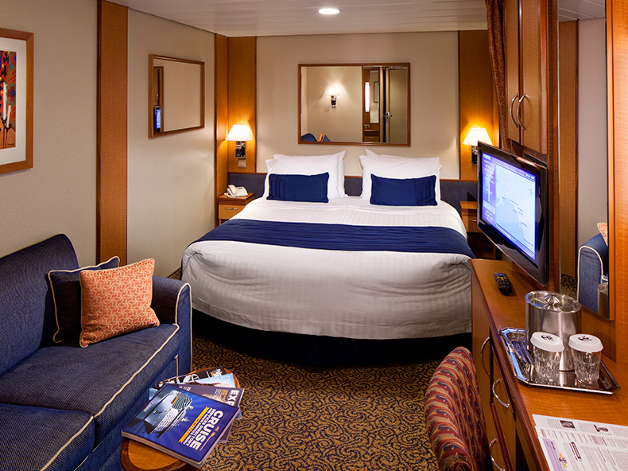
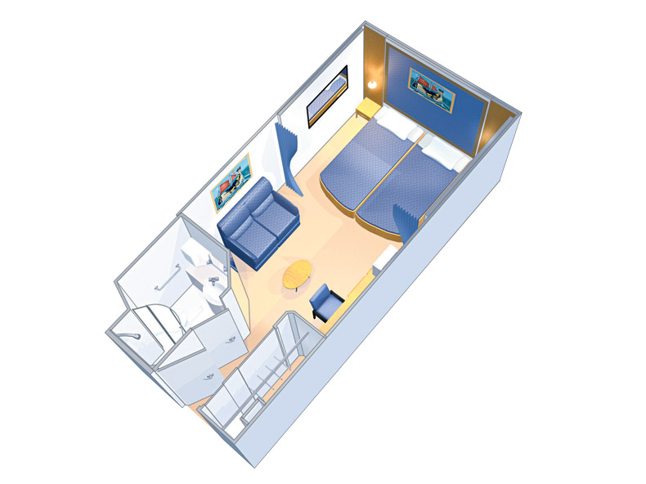
Inside:
This standard stateroom offers two twin beds, a private bath and all the amenities of standard staterooms. Amenities include 2 twin beds (can convert to a Royal King, measuring 72.5 inches wide by 82 inches long), Pullman beds, can accommodate 2-4 guests, 160 sq. ft., sitting area, vanity area, minibar, hair dryer, tv, phone, 110/220 electrical outlets, and more.

All stateroom images are representative samples and actual staterooms may differ in appearance. Stateroom availability is subject to change without notice. Please contact us for more details.

Serenade of the Seas

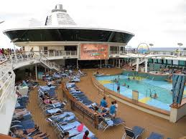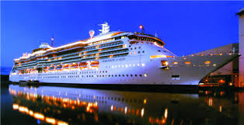

Ship Highlights

Explore Serenade of the Seas®, a dreamlike ship that's sleek and sunlit, with panoramic vistas and wide-open spaces at every turn. Enjoy an amazing view with the ship's floor-to-ceiling glass windows, relax by the tranquil adults-only Solarium pool*, and so much more.

- Poolside, outdoor movie screen
- Stateroom enhancements such as flat-screen televisions and new shower floors
- VitalitySM Spa featuring a wide array of treatment options**
- 6 pools and whirlpools, including the adults-only Solarium***
- Centrum aerial entertainment, featuring daring acrobatic shows set against artful lighting and LED screens
- R Bar, a retro-glamorous bar with iconic furnishings and signature cocktails
- Vintages wine bar—an intimate retreat with innovative wine dispensing system
- Complimentary Broadway-style entertainment in the three-story Tropical Theater
- 16 bars, clubs and lounges that never have a cover, including The Safari Club with self-leveling pool tables
- Giovanni’s Table Italian trattoria†
- Chef’s Table intimate dining experience†
- Izumi Japanese cuisine featuring à la carte sushi selections†
- Rita’s Cantina featuring Mexican fare and margaritas†
- Complimentary Park Café
- Complimentary multi-course breakfast, lunch and dinner in the Reflections Dining Room
- More complimentary options including the Windjammer Marketplace, pizzeria and Seaview Café

The excitement never stops on a
Card Player Cruises poker cruise!

Poker Room

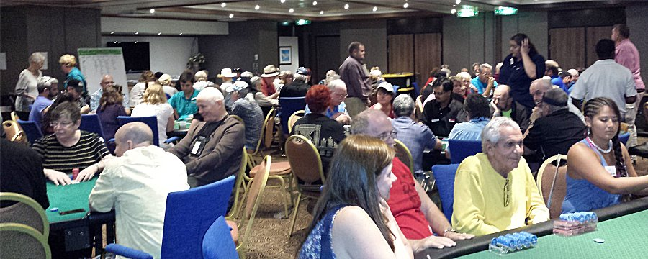

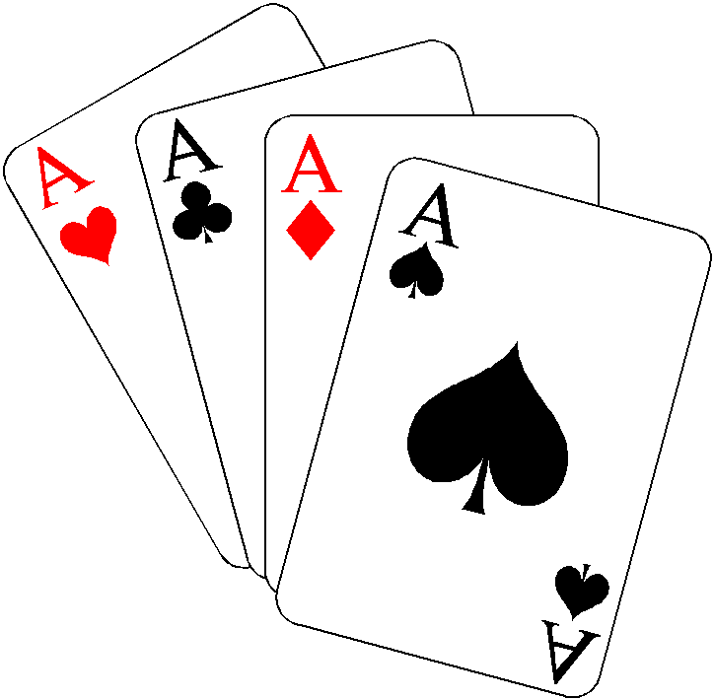

Card Player Cruises proudly features a professional, fully staffed, non-smoking poker room. The poker room is usually open for play immediately after the first-seating dinner on your departure day. The poker room remains open throughout most of the cruise except when the ship is in port.

Free beginner lessons for novices are offered, followed by a low limit hold’em game for beginners only.

The Card Player Cruises staff will be happy to spread any game and limit that enough players want to play.

A general guideline regarding the games and limits on most cruises is as follows:
Limit hold’em: $2/$4 - $4-$8 and higher upon request
No-limit hold’em: $1/3, $2/5, and higher upon request
Omaha/8: $4/8 and often higher ($10/20 on up)
Mixed games: Mixed games upon request
Tournaments will be announced.
Please contact our office for further details.

All poker games are open to anyone 18 years and older.

Great poker action - Exciting ports

Don’t miss this cruise!

